
Jane Doe
Branch Manager




CAKE & BAKERY
Sweet
Craft
Sneha gawade

s
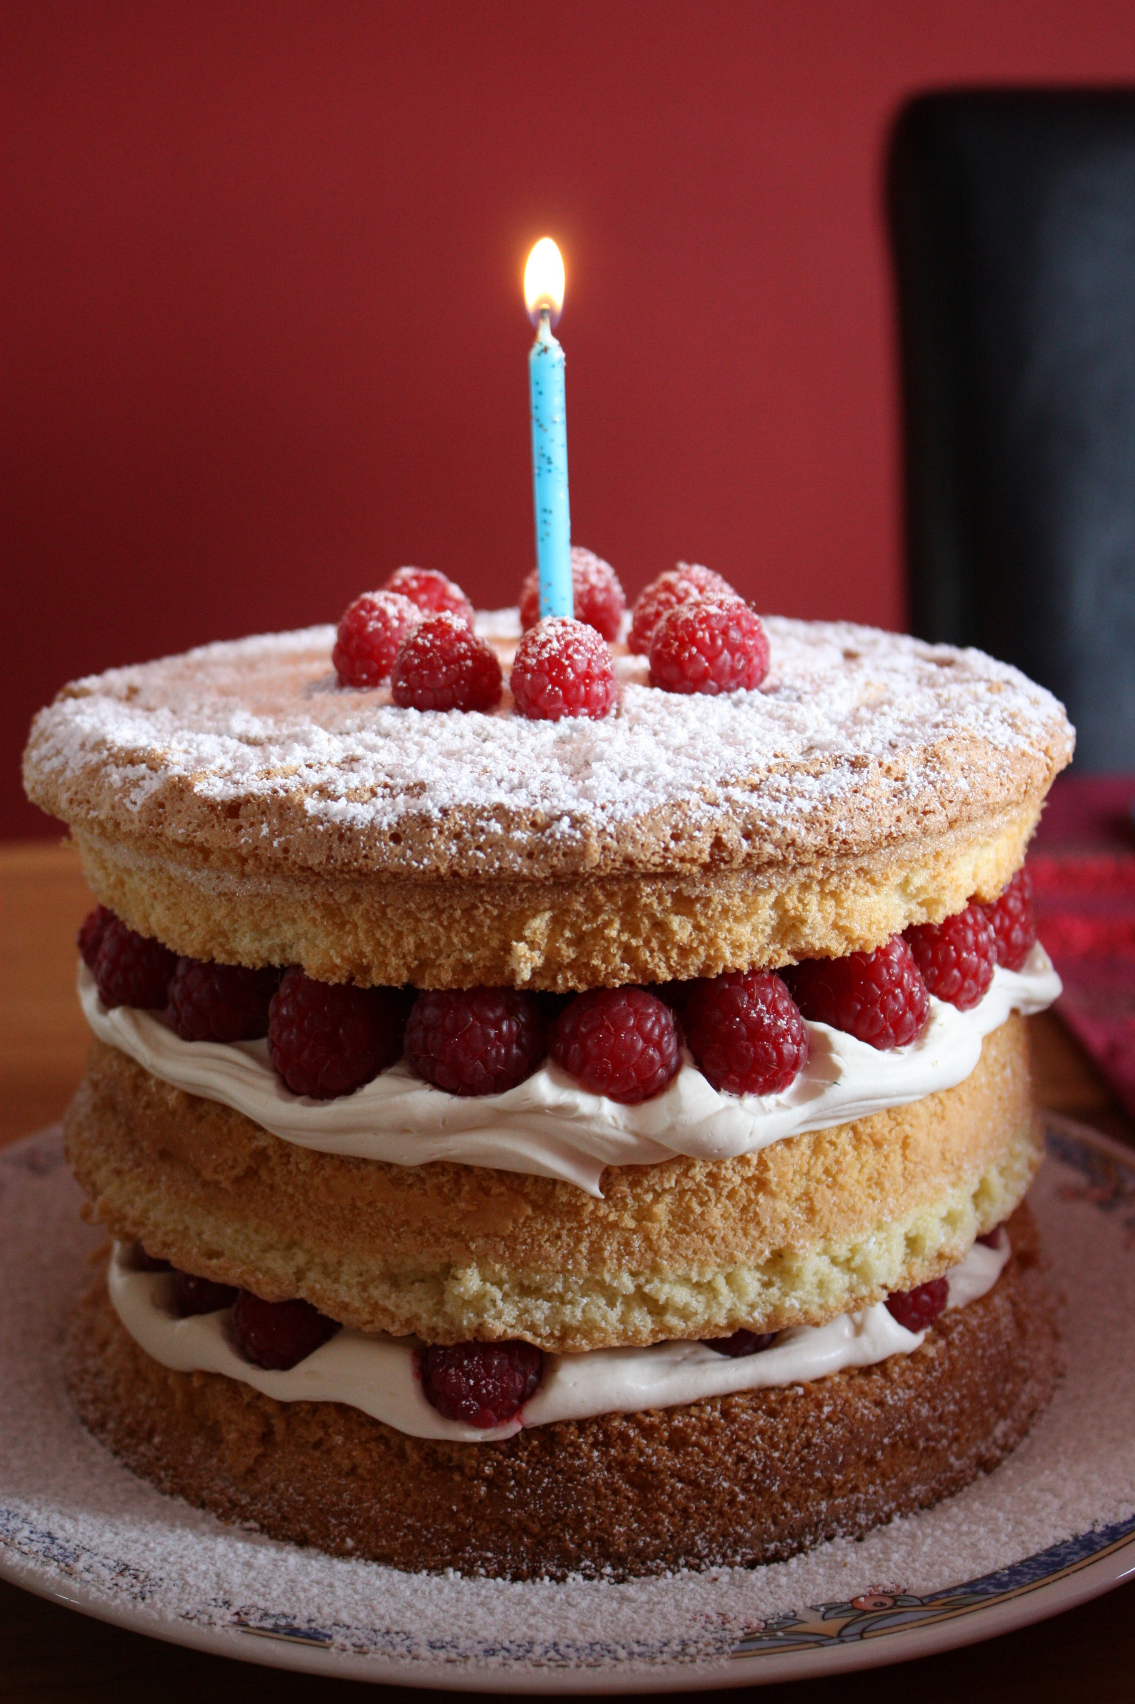
j

9420710443
@snehagawade190
Amboli Faujdarwadi

